CALL FOR SUBMISSIONS:
Community engagement for inclusive rural transformation and gender equality
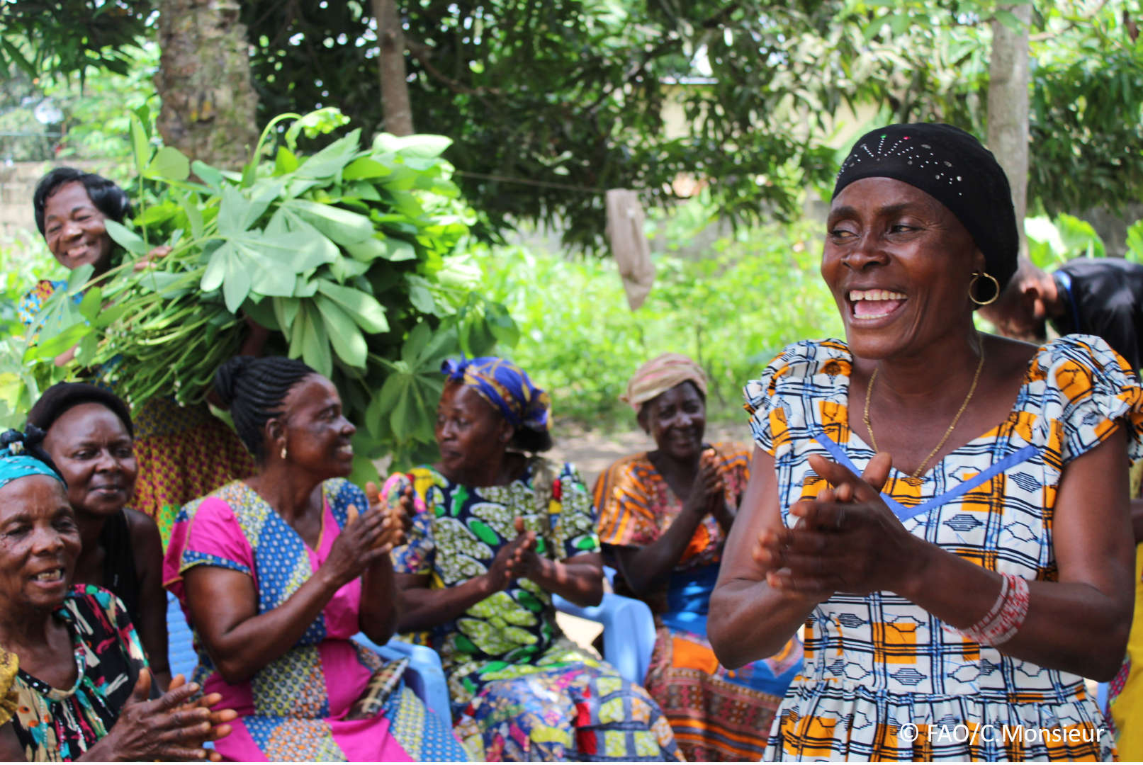
The objective of this call for submissions is to collect good practices, experiences, and lessons learnt on the use of community engagement for inclusive rural transformation and gender equality. The initiative, organized by the Rural Transformation and Gender Equality Division (ESP), seeks to gather insights from a diverse range of contributors, both within FAO and from external stakeholders. Its goal is to share knowledge, foster learning, and guide the scaling up of community engagement and community-led collective action to leave no one behind. The call builds on FAO's past efforts in this area, such as the Community Engagement Days series of webinars.
The call for submissions is open until 27 November 2024.

How to take part in this call for submissions:
To take part in this Call for submissions, please register to the FSN Forum, if you are not yet a member, or “sign in” to your account. Please review the topic note to understand the criteria we are considering for this call. If you wish to learn more about community engagement, you may refer to the background document. Once you have completed this submission template, upload it in the box “Post your contribution” on the call webpage, or, alternatively, send it to fsn-moderator@fao.org.
Please keep the length of submissions limited to 1,500 words and feel also free to attach relevant supporting materials.

Template for submissions

Contact person | Name: Anna E  Organization/Unit: We Effect/International Department  Country: Sweden  Email address: anna.edgren@weeffect.org
Name/title of the good practice | VILLAGE SAVING & LOANS GROUPS  A corner stone for women’s rights & community development
Where is the good practice taking place? (Multiple selection allowed) | ☐ Europe and Central Asia  ☒ Latin America and the Caribbean  ☐ North Africa and Near East  ☒ Sub-Saharan Africa  ☒ Asia and the Pacific  ☐ North America  ☐ Global
Affiliation | ☒ Farmer and producer organizations  ☐ Trade Union  ☒ Informal community-based, farmer-based or self-help group  ☐ Research and academia  ☐ Government  ☐ Local/traditional authorities  ☐ Private Sector  ☒ Civil Society Organization  ☐ Intergovernmental Organization (e.g. UN system, World Bank)  ☐ Resource Partner/Donor  ☐ Other (please specify)
In which sector(s) and context (s) have you used this community engagement good practice? (Multiple selections allowed) | ☐ Education  ☐ Health and Sanitation  ☒ Food production in agrifood systems (please also tick the sub-categories)  ☒ Crop cultivation  ☐ Fisheries and aquaculture production  ☒ Livestock  ☒ Forestry  ☒ Agroforestry  ☒ Horticulture  ☒ Apiculture (beekeeping)  ☒ Agroecology and sustainable farming practices  ☐ Soil and water management  ☐ Other: ____________  ☒ Post-production in agrifood systems (please also tick the sub-categories)  ☒ Processing and value addition  ☒ Marketing and retailing  ☐ Transporting  ☒ Food loss and waste  ☐ Packaging  ☐ Storage  ☐ Distribution  ☐ Other _________  ☒ Gender Equality  ☐ Climate Action  ☐ Citizenship and Governance  ☒ Social Protection  ☐ Humanitarian and protracted crisis  ☐ Conflict resolution, peace and resilience  ☐ Digital innovation  ☐ Other sector (please specify) _________
Who are the financial partners supporting this good practice, if applicable? | Swedish International Development Agency (Sida Civsam)
- In a few sentences, summarize your community engagement good practice.
We Effect has been promoting and facilitating the Village Saving & Loaning Associations (VSLAs) methodology as a tool for inclusion and economic development. We Effect, through partners mobilises women, young people and men mainly living in rural areas and engaged in subsistence agriculture and small business to form economic interest groups in this case VSLAs. Women and young people have been prioritised because We Effect is aware that this category continues to experience barriers and exclusions in multiple sectors and services e.g. financial services, enterprise strengthening opportunities, leadership among others. The formation of the groups is through self selection and very localised, same village, same marketplace etc. The purpose of these groups is to build capital through own savings and lend to each other amounts which the group predetermines. All decisions are carried out in a participatory manner, involving everyone. We Effect has worked with these groups with great results and evident impact. This methodology/community engagement intervention has proven to be very inclusive hence strengthening ownership and sustainability of the groups. To ensure systematic implementation and learning, We Effect has documented the process and success stories that demonstrate VSLAs as a corner stone for women’s rights & community development. Through the VSLA methodology, We Effect, and partners have reached over 800,000 women and young people with financial services and products over the last 5 years. This has contributed to increased engagement in income generating activities leading to regular cash flows for those who participate.

- What problem(s) or challenge(s) does your good practice aim to address through community engagement?
Through the VSLA methodology, We Effect addresses the following challenges: exclusion from mainstream financial services due to non inclusive policies, terms and conditions, lack of sufficient information on the financial services available to them, and how to access them. Harmful social norms and practices also lead to exclusion of women and young people from financial institutions. Location of financial institutions is often far hence inaccessible, finally, care work has continued to limit women’s participation in financial services and doing business.
As such, We Effect recognises the VSLA methodology as a vehicle to inclusion and engagement, where women, young people and men create their own financial institutions on their own terms and condition, closer to them to access capital and other financial services.
The methodology provides a much-needed solution to barriers related to access financial services such as lack of collateral, stringent terms and conditions from financial institutions, complex application processes, limited physical access to financial institutions, prohibitive interest rates and caps on minimum transaction amounts. These barriers among others keep people living in poverty on the margin and in a vicious cycle of poverty.

- Describe your good practice in more detail. Include the main guiding principles, the desired changes or outcomes you aim to achieve (Theory of Change), and the key phases of implementation.
Village Savings and Loaning Association (VSLA) methodology is an inclusive life changing approach, which seeks to strengthen capacities of low-income earners especially women and young people living in poverty with limited economic capacities. The methodology strengthens capacity of women and young people to meaningfully participate in the groups to save, borrow and belong to welfare which acts as a social safety net. Further, the methodology facilitates knowledge and skills that enable the women and young people to engage in productive businesses, secure an income and enjoy sustainable livelihoods. VSLAs therefore provide accessible source of capital for women and other marginalised groups to start up and run their own businesses and provide for family needs. In addition, the VSLA groups receive training on leadership, gender equality, environment and climate change hence being an avenue for members to gain knowledge and skills beyond money and business matters. These groups have provided women with opportunities to exercise their leadership skill as well as enhance decision-making within households, cooperatives, and communities. The VSLAs are self-managed and have encouraged women to step up and take up leadership roles that often have led to other aspects beyond economic autonomy for the women, such as strengthened communities.
Desired outcomes
- Women and young people participating in strong, well managed VSLAs
- Increased number of women accessing affordable financial services
- Increased number of women applying their skills in doing business start-up or expansion)
- Progression of VSLAs to the next level as a means towards financial inclusion

Guiding principles
The guiding principles of this approach are;
Human Rights-Based Approach: VSLAs are built on principles of respect, non-discrimination, participation, aligning with broader human rights goals to support dignity, empowerment, and social justice for all members.
Inclusivity: VSLAs espouse inclusivity, especially for women and young people. The focus on participatory formation of the groups ensures that the terms and conditions of joining do not leave anyone out.
Ownership: VSLAs are typically member-owned and member managed which motivates members to take ownership of group decisions, financial policies, and internal regulations, which strengthens the commitment and accountability within the group.
Transparency: Ensuring transparency in group transactions, savings, and loaning and repayment process is essential. This is done openly during group meetings. Record-keeping, open meetings, and clear rules on loan repayment and savings help build trust among members and help members to make informed financial decisions, improving the sustainability of the group and empowering individuals to manage their resources effectively.
Flexibility: Savings and Loaning groups have flexible structures that allow for adaptation to the unique contexts. This flexibility is necessary for adjusting savings requirements, loan terms, or meeting schedules according to members’ seasonal income flows or community-specific conditions.

Theory of Change
We Effect believes that access to savings, credit, financial literacy coupled with business development skills, leadership, strengthened voice and choice are key to realization of economic independence and improved livelihoods. As such, strengthened VSLAs are key entry points to economic, social, political and environmental changes.
IF We Effect provides the necessary resources (technical and financial) and supports communities through partners to form and efficiently run their own VSLAs,
IF VSLA members receive training in financial literacy, gender quality, entrepreneurship, climate resilience and leadership,
THEN they will actively manage and participate in functional VSLAs, access opportunities for affordable and accessible financial services, increase their savings and loaning. More, women and young people will engage in income generating activities and diversity their sources of income,
Women will strengthen their decision-making power at household and community levels,
THEN women and young people will achieve economic and social independence, meet their financial needs, improve livelihoods, enhance their resilience and enjoy a better life free from poverty and injustice

Key phases of implementation of VSLAs
- Establishment of partnership with implementing partner
- Community mobilisation and creating awareness of the methodology
- Formation of savings and loaning groups
- Training on group dynamics and management
- Training on financial modules which cover savings, loans and social fund.
We Effect has adapted the methodology guided the various contexts and emerging needs to include:
- Trainings on entrepreneurship and debt management, insurance, environment and climate change, gender equality
- Digitalization of VSLA operations to improve reach, security of money and convenience,
- In Palestine, the team has adopted Sharia-compliant VSLAs to take care of the religious contexts, ensuring inclusivity. ​
- Gender and social norms training has been integrated into VSLA training to address harmful norms

- Who are the key actors and stakeholders involved in the design and implementation of the good practice, and what are their respective roles? Consider local partners, government, local authorities, community radios, civil society, research, the private sector, etc.
The key actors in the VSLA methodology are the numerous women, men and young people living in poverty and on limited financial resources in rural areas. This methodology is implemented by partner organisations who are mainly farmer-based organisations and NGOs. The role of partner organisations is to facilitate formation, strengthening of VSLAs and engaging in monitoring. On the other hand, We Effect provides technical support and the financial resources to implement the methodologies.

- How does your intervention ensure inclusivity and equal and meaningful participation within the community?
The VSLA methodology promotes membership through self-selection, therefore membership is open to anyone who becomes interested. To ensure inclusivity, the process of joining and participating is simple and straight forward. It starts with community sensitisation on the methodology and its purpose. The amount to save and borrow are discussed in a very transparent manner with members proposing a range of share value. The minimum share value ensures that all group members came afford the share value. In addition, the frequency of saving and loan repayment is determined by the group and in a participatory manner. The methodology promotes self-selection, there is no age, disability status, level of income. The main requirement for joining the group is interest and willingness to participate in its activities. In addition, to enhance inclusivity, We Effect uses the principle of leave no one behind, gender transformative approach, intersectionality as well as sustainable livelihoods approaches to support holistic community development.
- By using community engagement, what results and impacts have your good practice achieved?
The VSLA methodology has significantly contributed to women's economic empowerment, social cohesion, and community development hence demonstrating its effectiveness as a tool for financial inclusion, economic development and poverty reduction. ​
We Effect has many case studies demonstrating the impact of VSLAs amongst the target group.
Outreach: We Effect, and partner organizations have reached 811,000 members in VSLAs, with 90% being women. ​Approximately 13,000 VSLAs were formed between 2018-2022, across East Africa, Palestine, Malawi, Sri Lanka, Zimbabwe, and the Philippines. ​

- Among these results, has the good practice led to improvements in terms of gender equality, women’s empowerment, and/or social inclusion?
Economic Empowerment: VSLAs have enabled women to access capital, start businesses, and achieve economic autonomy. ​Women have used loans to invest in income-generating activities, such as farming and small businesses, leading to increased household income and financial stability. ​
Social development: ​VSLAs have fostered social cohesion, trust, and solidarity within communities. ​Women have gained leadership roles and decision-making power within households and communities. ​VSLAs have provided safe spaces for women to discuss and address social issues, enhancing their collective voice and capacity. ​
Some examples:
- In Guatemala, VSLAs helped women maintain economic activities during the Covid-19 pandemic, providing food and income when state support was lacking.
- In Zimbabwe, women dairy farmers have used VSLA savings to invest in livestock and improve milk production, leading to increased profits and ownership.
- In the Philippines, VSLAs have strengthened social networks and economic capacities among indigenous communities, fostering community development. ​​
- What key challenges did you encounter while implementing the community engagement activities, and how did you address them?
Women gaining economic independence and leadership roles through VSLAs may face backlash, including intimate partner violence. This is one aspect that came out clearly during a baseline study in northern Uganda. Women expressed concern that their economic independence could result in gender-based violence. We Effect responded by organising gender equality training targeting the community.​ In addition, it was necessary to address harmful patriarchal norms and ensuring constructive masculinity through focus groups.

The onset of Covid-19 affected how groups were transacting their business. This is when We Effect encouraged groups to use mobile money where that was possible.
In some countries, government requirements for VSLA formation and operation can be restrictive and bureaucratic. For instance, in Sri Lanka, partner organisations must inform the government departments before promoting VSLAs, a process which can delay implementation. ​
Traditional gender roles and stereotypes can limit men's participation in VSLAs and place additional responsibilities on women. ​However, this has been addressed through gender equality training, encouraging male engagement and addressing social barriers.

- What are the key lesson learned from your community engagement good practice?
The key lesson learnt is that groups have the capacity to run their affairs sustainably and even graduate to the next level provided they are supported to internalise the VSLA concept, own the process and trust each other.
- Has this practice been replicated in the same context or in different contexts?
We Effect continues to replicate the VSLA methodology in most of the countries of operation. Implementation is adapted to the conditions of the various contexts and needs of community members. Implementation in new areas is informed by the context, resources and lessons learnt in previous interventions.
- How sustainable are the results achieved by this good practice?
Groups are normally encouraged to adopt policies that contribute to long term sustainability, such as fair interest rates and savings requirements. Some groups may establish emergency funds or social welfare mechanisms to support members in times of crisis.
- Based on the conversations FAO held during the Community Engagement days, a definition of community engagement for empowerment was proposed:

“Community engagement for empowerment and community-led collective action can be defined as an inclusive and participatory process that enables supports community members to become active agents of change in decisions affecting their lives, livelihoods, health, and environment. This process develops strengthens their capacity to participate and achieve pursue sustainable outcomes for improved rural their livelihoods. Embracing a rights-based approach, it prioritizes the agency and participation of all community members, regardless of gender identity, socioeconomic status, sexual orientation, age, ethnicity, caste, , political affiliation, migration status, or ability/disability. Indeed, inclusive approaches recognize the complexities of overlapping marginalization and discrimination that can exclude different community members from decision-making processes and implement strategies to foster their participation, agency and empowerment.”

“Community engagement for empowerment and community-led collective action can be defined as an inclusive and participatory process that prioritises community members’ voice and choice and supports them to become active agents of change in decisions affecting their lives, livelihoods, health, and environment. This process strengthens their capacity to participate and pursue sustainable outcomes for their livelihoods. Embracing a rights-based approach, it prioritises the agency and participation of all community members, regardless of gender identity, socioeconomic status, sexual orientation, age, ethnicity, caste, political affiliation, migration status, or ability/disability.

- Based on your experience, what gaps or areas for improvement still need to be addressed in the field of community engagement?
In my view the area for improvement in the field of community engagement is upscaling interventions that target communities. There are still more women and young people who are excluded from mainstream services. In addition, to reach more community members, it would be valuable to create and strengthen a movement of organisations who are working with community engagement to come together in a round table and agree on how to complement each other.

What do you think is FAO's role in the field of community engagement? How can FAO support and enhance interventions like yours, if applicable?
Some possible ways for FAO to expand contribution to community engagement specifically and in general are;
- FAO could enhance their support upscaling of the implementation of the VSLA methodology. This would take the intervention to areas where it has not been widely promoted and the need for financial services for those living in poverty is still evident.
- FAO could also play a critical role in bringing together organisations that are working with specific community engagement interventions to form networks or consortia to expand outreach and enhance efficiency in reaching more communities. This would mean sharing areas where each organisation is working, seeking collaborations and or partnerships.
- FAO could support the process of graduation of VSLAs to the next level such as forming and strengthening Savings and Credit Cooperatives. This would afford the groups access to bigger amounts of loans in a sustainable manner.
- FAO to continue working together with like-minded organisations to facilitate knowledge production and sharing through foras. For example this new initiative (collecting information, experiences) is a great step or others whose nature and frequency could be further discussed and fine-tuned.

Link(s) to specific references about your good practice (e.g. reports, communication products, videos, articles) | Please include attachment(s) or add here link(s) to documents/videos/podcasts/other with specific references.  https://acrobat.adobe.com/id/urn:aaid:sc:EU:42c67ea6-92b7-418f-859c-5c3ee542c52e

The call for submissions is directly aligned with the thematic components of collective action within FAO's Programme Priority Areas (PPAs), specifically Better Life 1 (Gender Equality and Rural Women’s Empowerment), Better Life 2 (Inclusive Rural Transformation) and Better Life 3 (Agriculture and Food Emergencies).

